1. In the SAP easy access menu type SE38 and press enter.

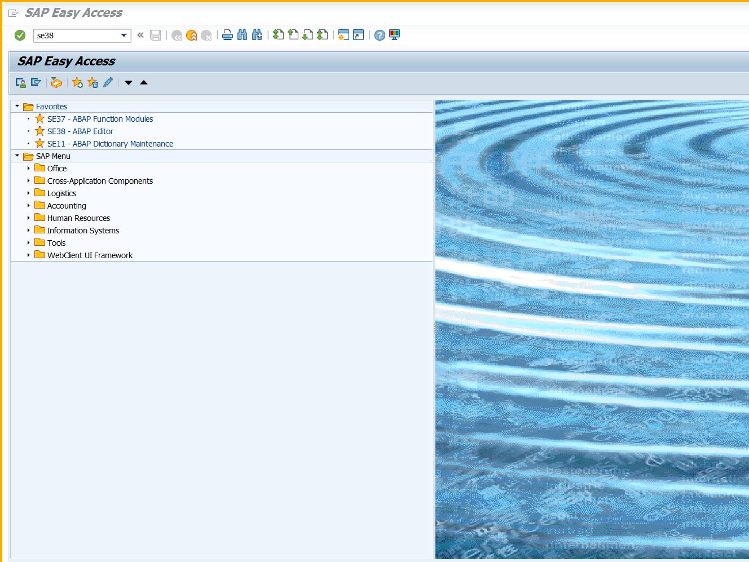

1. Enter program name as shown below.

Name of program is zxxxxxxpgm1

Where xxxxxx is your empcode

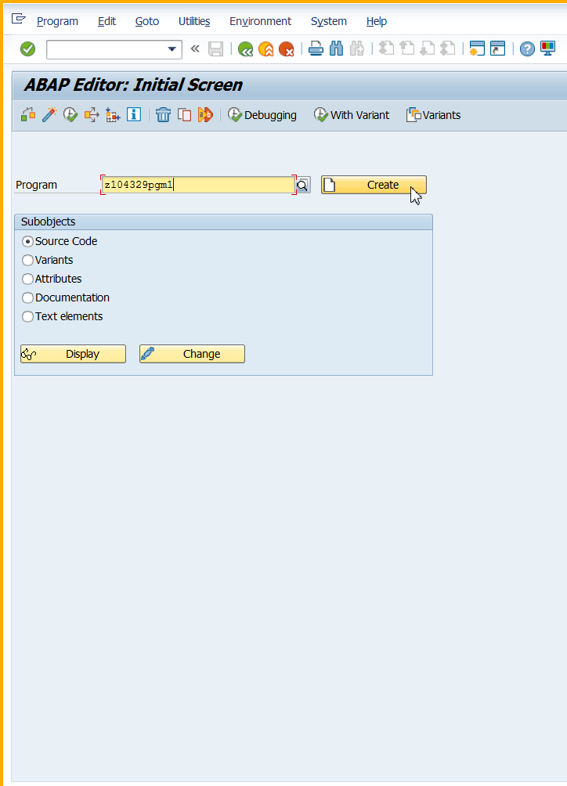

1. Enter title and select type executable.

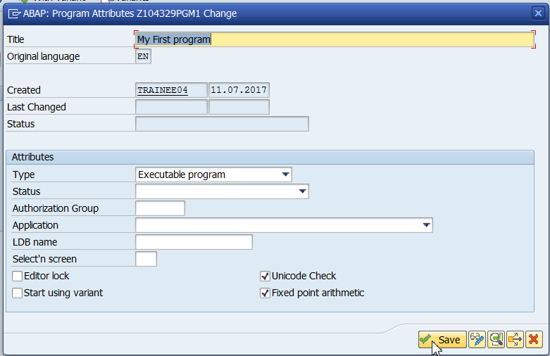

Click on save.

1. Save it as a Local Object.
2. Check the program.

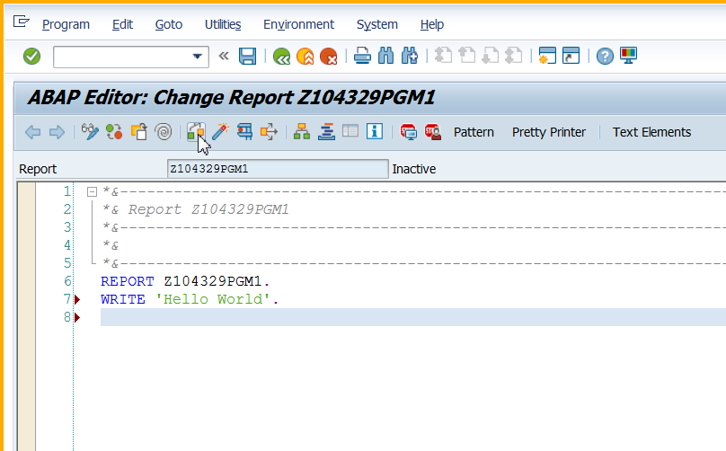

1. Save the program. Activate the program.

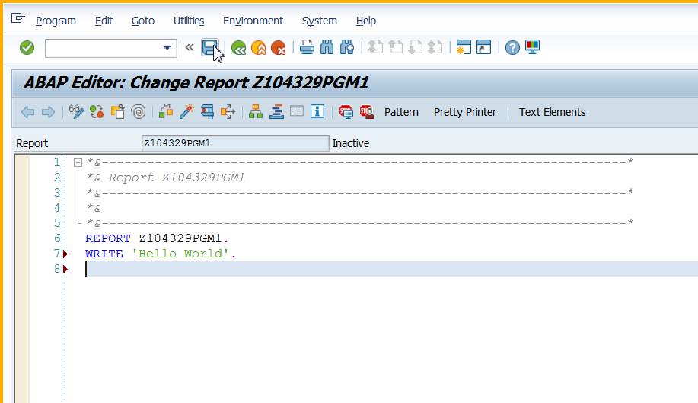

1. Execute the program

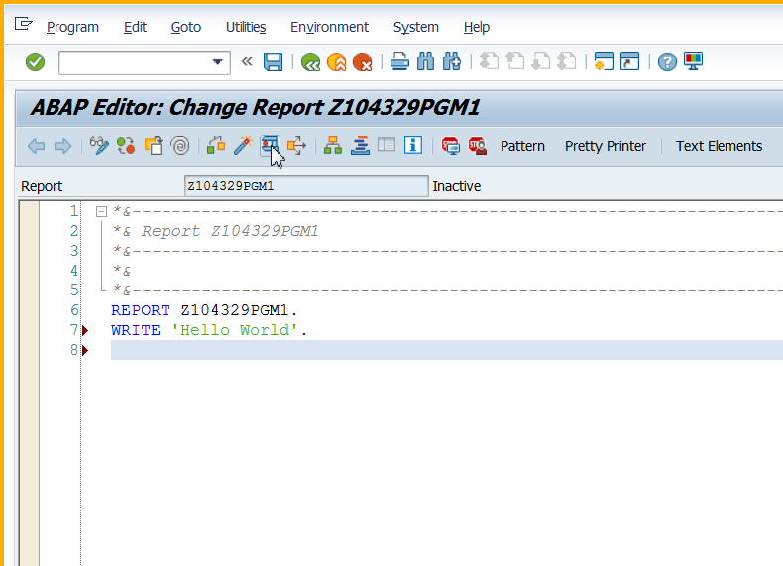

1. See the output

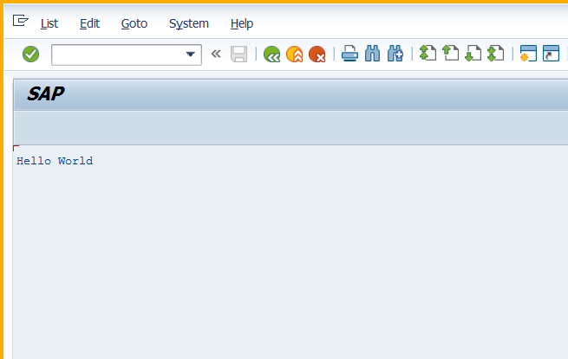

1. Press the back button to go back to the editor window.

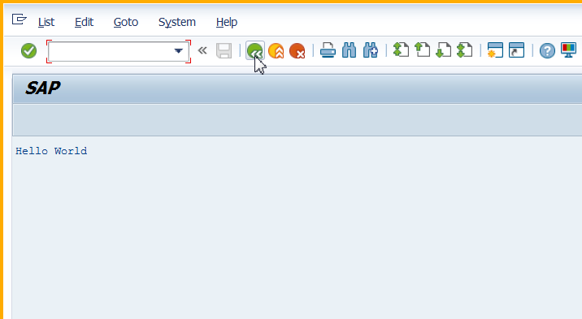

1. Back to editor window.

